|  |  |  |
| --- | --- | --- |
| **EX. No: 1** | **INSTALLATION OF GIT AND MANAGING PUBLIC AND PRIVATE REPOSITORIES.** | **Reg No. URK23CS7001** |
| **12.12.2023** |

# Introduction of GIT

Git is one of the ways of implementing the idea of version control. It is Distributed Version Control System.

# Installing GIT

|  |
| --- |
| Before you start using Git, you have to make it available on your computer. Even if it’s |
| already installed, it’s probably a good idea to update to the latest version. You can either install |

it as a package or vi

a another installer, or download the source code and compile it yourself.

# Installing on Windows

There are also a few ways to install Git on Windows. The most official build is available for download on the Git website. Just go to <https://git-scm.com/download/win>and the download will start automatically

To get an automated installation you can use the [Git Chocolatey package.](https://community.chocolatey.org/packages/git)

The easiest way to get Git is to download the executable from [the Git website.](https://git-scm.com/download/win)

Click "64-bit Git for Windows Setup" to start the [download,](https://www.howtogeek.com/771533/where-are-my-downloads-on-windows/) and then wait a moment — the download is only about 50 megabytes, so it shouldn't take very long.

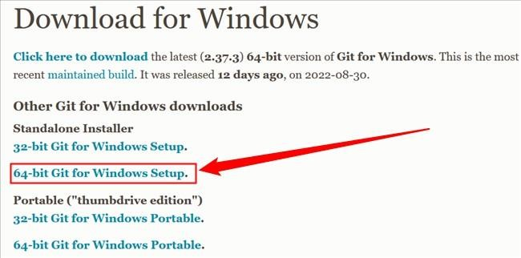

Double-click the executable you just [downloaded,](https://www.howtogeek.com/771533/where-are-my-downloads-on-windows/) then click "Next" to move through the installation prompts.

The first is the text editor Git will use. The default selection is Vim. Vim is ubiquitous and a hallmark of command-line interfaces everywhere but learning to use its idiosyncratic commands can be daunting. You should probably pick something else instead, like Visual Studio Code, Sublime, NotePad++, or any other [plain text editor](https://www.howtogeek.com/795509/why-you-need-a-plain-text-editor/) you like.

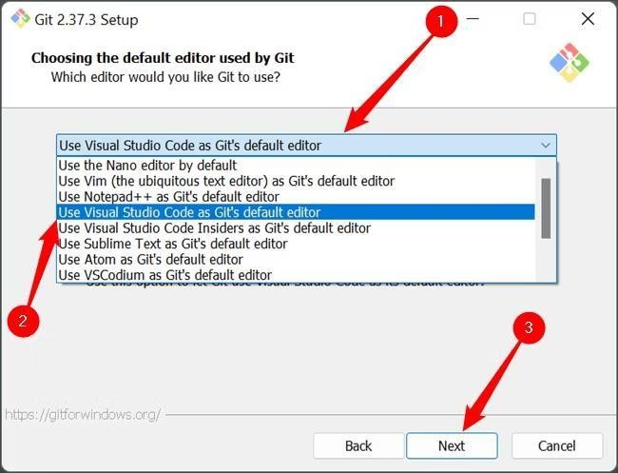

The second is the way Git integrates itself into your PC's [PATH.](https://www.howtogeek.com/118594/how-to-edit-your-system-path-for-easy-command-line-access/) Make sure that the "Git From The Command Line And Also From 3rd-Party Software" is selected.

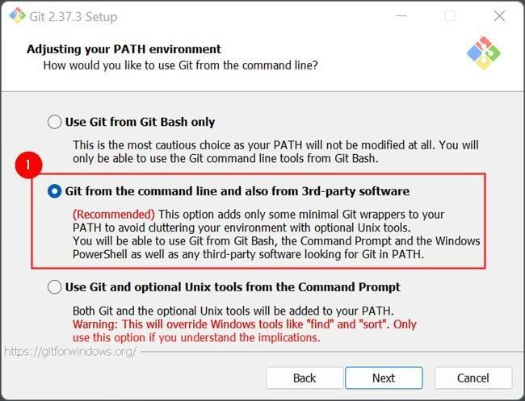

Click through the remaining options, and wait for everything to finish downloading. The time requires to download everything will vary depending on what you chose to install. The default selection results in a download that is about 270 megabytes.

**Managing Private and Public Repository**

**Making a repository Private**

* GitHub will detach public forks of the public repository and put them into a new network. Public forks are not made private.
* If you're using GitHub Free for personal accounts or organizations, some features won't be available in the repository after you change the visibility to private. Any published GitHub Pages site will be automatically unpublished. If you added a custom domain to the GitHub Pages site, you should remove or update your DNS records before making the repository private, to avoid the risk of a domain takeover. For more information, see "[GitHub’s plans"](https://docs.github.com/en/get-started/learning-about-github/githubs-plans) and "[Managing a custom domain for your GitHub Pages site.](https://docs.github.com/en/pages/configuring-a-custom-domain-for-your-github-pages-site/managing-a-custom-domain-for-your-github-pages-site)" ● GitHub will no longer include the repository in the GitHub Archive Program.
* GitHub Advanced Security features, such as code scanning, will stop working.

## Making a repository Public

* GitHub will detach private forks and turn them into a standalone private repository.
* If you're converting your private repository to a public repository as part of a move toward creating an open source project, see the [Open Source Guides](http://opensource.guide/) for helpful tips and guidelines.
* Once your repository is public, you can also view your repository's community profile to see whether your project meets best practices for supporting contributors.
* The repository will automatically gain access to GitHub Advanced Security features.

## Changing a repository’s Visibility

1. On GitHub.com, navigate to the main page of the repository.
2. Under your repository name, click **Settings**. If you cannot see the "Settings" tab, select the dropdown menu, then click **Settings**.

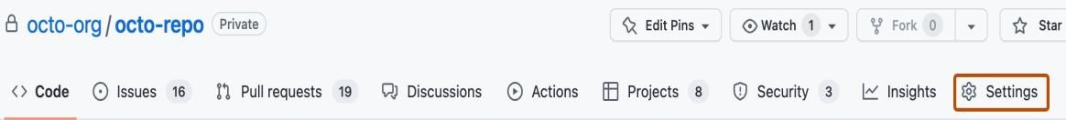

1. In the "Danger Zone" section, to the right of to "Change repository visibility", click **Change visibility**.
2. Select a visibility.
3. To verify that you're changing the correct repository's visibility, type the name of the repository you want to change the visibility of.
4. Click **I understand, change repository visibility**.